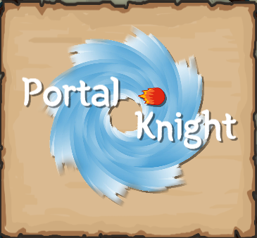

**Design Document for:**

# Portal Knight

**The Platformer with a TWIST!**

Written by Nicholas Murray

Version # 1.00

Friday, March 01, 2019Table of Contents

Portal Knight 1

Game Overview 3

Game Design Goals 3

Common Questions 4

What is the game? 4

Why create this game? 4

Where does the game take place? 4

What do I control? 4

What is the main focus? 4

Feature Set 4

General Features 4

Gameplay 5

The Game World 6

Overview 6

Circular Platforms 6

The Physical World 6

Overview 6

Travel 6

Objects 6

Camera 7

Overview 7

Game Engine 7

Overview 7

Collision Detection 7

Game Characters 8

Overview 8

Enemies and Monsters 8

User Interface 9

Overview 9

Musical Scores and Sound Effects 10

Overview 10

Single-Player Game 11

Overview 11

Story 11

Victory Conditions 11

Artwork and Sounds 12

References 13

“Objects Appendix” 13

*Figure 1:* (Platform Clusters) 13

*Figure 2:* (Foliage/Shrubs) 14

*Figure 3:* (Fireballs) 14

*Figure 4:* (Gold coins) 14

*Figure 5:* (Slime) 14

*Figure 6:* (Hero) 15

*Figure 7:* (Bee) 15

*Figure 8:* (Mosquito) 15

*Figure 9:* (Dragonfly) 16

“User Interface Appendix” 17

*Figure 10:* (User Interface) 17

# Game Overview

## Game Design Goals

The original design idea for this game was to create multiple worlds that the player could rotate/run around and jump for one to another like they would platforms in a traditional platformer. After playing around with a quick prototype of the game to test the mechanics I decided it would be more engaging to have multiple layers in each world which soon just became circular platform clusters rather than a world.

## Common Questions

### What is the game?

This game is a platformer with a bit of a twist, the twist is that the platforms are circular and the player gravitates towards the center of the platforms instead of vertically downward like traditional idea of gravity. There is also a mix of labyrinths and swarms of enemies to navigate around.

### Why create this game?

I created this game because I like to create games that use concepts or features that I have never seen before in other games. I also make games in my spare time as a hobby so I jumped at the opportunity to enter a game in a competition.

### Where does the game take place?

The game takes place in a world of Magic, Knights and Monsters. You play as Knight who has found himself stuck in a magical swamp that warps gravity in mysterious ways. You need to find your way through the multiple levels of labyrinths and monsters.

### What do I control?

You control a Knight who can cast fire balls to attack his enemies.

### What is the main focus?

The main focus of each level is to find the portal at the end of each level. Other goals are to get a high score by destroying all the enemies in your way and collecting gold coins.

# Feature Set

## General Features

* Simple interface design, so there’s no getting lost in menus
* Game automatically saves your progress after each level and keeps track of your scores

## Gameplay

* Simple controls that are easy to master
* Shoot fireballs as fast as you can press the button
* Multiple labyrinths to find your way out of
* Multiple different swamp monsters to fight/avoid
* Health potions hidden throughout each level
* Collect gold coins to get more lives

# The Game World

## Overview

The game takes place in a magical world of heroes and monsters. You play as a knight who has found himself stuck in a mysterious swamp which is full of monsters that want to serve him up for dinner.

## Circular Platforms

The world is made up of multiple clusters of circular platforms which the player rotates around to maneuver around the world. The player falls towards the center of each of these clusters. The closer to the center the player is the stronger the gravity is and as a result he moves slower.

Once the player jumps towards a different cluster and gets close enough, he will start to fall towards it.

The platforms can rotate and expand outwards away from the center of the cluster making navigating the world even more difficult.

## The Physical World

### Overview

The world is made up of multiple different circular platforms which are constantly moving and changing making the world difficult to navigate and find your way out of.

### Travel

The player moves the character round the world by jumping between and running around each cluster of platforms. This is made difficult by the movement of the platforms.

### Objects

**Platform Clusters:** These are the main objects in the world as they are what make up each level (see [Figure 1](#_Figure_1:_(Platform))

**Foliage/Shrubs:** There are many different variations of these throughout the world however they all act in the same way. When the player collides with them, they play an animation and particle effects are emitted from them. They also have a random chance of spawning gold coins (see [Figure 2](#_Figure_2:_(Foliage/Shrubs)))

**Fireballs:** These are the projectiles of this world they explode on impact with most objects in the world and do damage to anything that has a health component. The player and the dragonfly enemies fire these although they’re not biased and will both damage either the player or enemies. One important note on the fireballs is that they do explode on impact with each other and this can be used as a very useful tactic to avoid taking damage. (see [Figure 3](#_Figure_3:_(Fireballs)))

**Gold coin:** These are the currency in the game world. When you collect 100 coins the player receives an extra life in exchange for the coins, this is useful when you’re on your last life and only halfway through level. (see [Figure 4](#_Figure_4:_(Gold))

## Camera

### Overview

The camera follows the player around the world with a slight smoothing so that it does not track every slight movement the player makes, which stops the camera movement being too abrupt or jittery.

.

## Game Engine

### 

### Overview

I used Unity 2018.3.0f2 personal edition to create this game.

### Collision Detection

The built-in Unity collision systems where used throughout the entire game to create a more immersive world, from colliding with the platforms that you walk on to the foliage that is littered around the world.

**Physics**

The Unity physics engine was used heavily in the game to create the character movement mechanics. Some of the objects such as the gold coins and enemies use the physics engine to attract them towards the platforms.

# Game Characters

## Overview

The main character in the game is a knight/mage who can project fireballs to kill his enemies. (see [Figure 6](#_Figure_6:_(Hero)))

The enemies are all insects that you would expect to find in a swampy environment plus the addition of a slime monster which is not an insect but also fits in well to the swamp theme.

## Enemies and Monsters

**Slime:** These are the most basic of the enemies in the game, they do not pose a threat however if you touch them, they will do damage to the player. They move around the world oblivious to the world around them. (see [Figure 5](#_Figure_5:_(Slime)))

**Bee:** This is first of the insect monsters that inhabit the world, it flies directly for player and stings when it gets close enough. The bee has a one second cool down between attacks. Its speed is medium meaning the you can outrun them but only if there is nothing to slow you down. (see [Figure 7](#_Figure_7:_(Bee)))

**Mosquito:** The Mosquito is the fastest enemy in the game and can keep up with the player in most situations. It only has a half second cool down time between attacks however it does less damage than the bee. The Mosquito changes in color and size the more times it attacks the player as it sucks their blood. (see [Figure 8](#_Figure_8:_(Mosquito)))

**Dragonfly:** The Dragonfly is the only ranged enemy in the game. It fires green fireballs since it is a “Dragon” after all. The Dragonfly has a one second cooldown between attacks. It is also the slowest moving enemy but has the most health. (see [Figure 9](#_Figure_9:_(Dragonfly)))

# User Interface

## Overview

The user interface is very simple so as not to distract the player from what is going on in the game although it still provides more than enough detail to keep the player aware of their current situation.

**Health Bar:** The health bar is exactly what it says on the tin. It ranges from 0 to 100.

(see [Figure 10](#_Figure_10:_(User) – in the top left corner)

**Lives:** The players current lives are indicated by three red hearts. The max lives the player can have is three. The hearts are animated and beat very slowly over time.

(see [Figure 10](#_Figure_10:_(User) –to right of the health bar)

**Score:** The score text keeps tracks of the players score on the current level. It is yellow so it is visible among the bark backgrounds in the game.

(see [Figure 10](#_Figure_10:_(User) – below the health bar)

**Timer:** The timer keeps track of the length of time the player has spent in the current level. (see [Figure 10](#_Figure_10:_(User) –below the score text)

**Coin counter:** The coin counter keeps track of the players current coin count unlike the score coins travel between levels with the player.

(see [Figure 10](#_Figure_10:_(User) – in the top right corner)

# Musical Scores and Sound Effects

## Overview

I decide not to use background music in the game and chose instead to have a nice swamp environment ambience. I think the combined with the sounds of the enemies the sound in the game turned out very immersive.

# Single-Player Game

## Overview

The single player game play experience is a platformer foremost but there is also a lot of puzzle solving with some bullet hell/ shoot’em up mixed in. Each level is designed to last from anywhere between one and six minutes depending on how good you are at mazes.

## Story

The hero finds himself stuck in a strange swampy world full of monsters and labyrinths. You must find your way through a series of puzzling levels while surviving the hoards of enemies that you will encounter.

.

## Victory Conditions

Reach the portal at the end of each level to complete the game. You can got back and try to beat your scores if you are a competitive person. There is a certain amount of replay ability to the game because of how the platforms move, most play throughs will go differently.

# Artwork and Sounds

Backgrounds (jkjkke, 2019)

Bottle breaking sound (spookymodem, 2019)

Coin sounds (Luke.RUSTLTD, 2019)

Coins (JM.Atencia, 2019)

Foliage sounds (qubodup, 2019)

Heart Icons (cdgramoso, 2019)

Insects (JustVic, 2019)

Keyboard key images (TRBRY, 2019)

Platform (pzUH, 2019)

Slime (AndHeGames, 2019)

Swamp sounds (LokiF, 2019)

Thorn Bushes (Studio, 2019)

# References

AndHeGames. (2019). *openegameart.org*. Retrieved from openegameart.org: https://opengameart.org/content/adorable-blue-slimegelliving-water-droplet

cdgramoso. (2019). *opengameart.org*. Retrieved from opengameart.org: https://opengameart.org/content/heart-1

jkjkke. (2019). *opengameart.org*. Retrieved from opengameart.org: https://opengameart.org/content/background-6

JM.Atencia. (2019). *opengameart.org*. Retrieved from opengameart.org: https://opengameart.org/content/spinning-coin

JustVic. (2019). *opengameart.org*. Retrieved from opengameart.org: https://opengameart.org/content/hungrychammy-images1

LokiF. (2019). *opengameart.org*. Retrieved from opengameart.org: https://opengameart.org/content/swamp-environment-audio

Luke.RUSTLTD. (2019). *opengameart.org*. Retrieved from opengameart.org: https://opengameart.org/content/10-8bit-coin-sounds

qubodup. (2019). *opengameart.org*. Retrieved from opengameart.org: https://opengameart.org/content/20-rustles-dry-leaves

spookymodem. (2019). *opengameart.org*. Retrieved from opengameart.org: https://opengameart.org/content/breaking-bottle

Studio, G. D. (2019). *opengameart.org*. Retrieved from opengameart.org: https://opengameart.org/content/thorn-bushes

TRBRY. (2019). *opengameart.org*. Retrieved from opengameart.org: https://opengameart.org/content/keyboard-keys

# “Objects Appendix”

## *Figure 1:* (Platform Clusters)

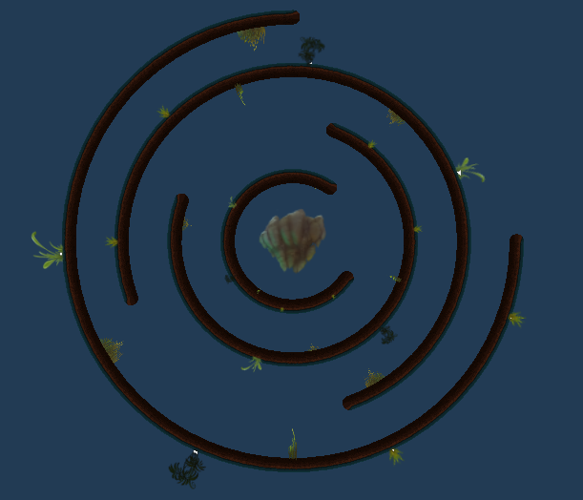

## *Figure 2:* (Foliage/Shrubs)

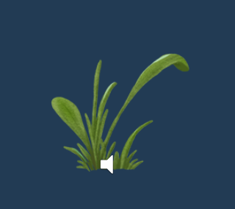

## *Figure 3:* (Fireballs)



## *Figure 4:* (Gold coins)



## *Figure 5:* (Slime)

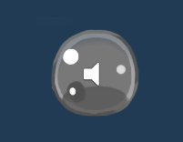

## *Figure 6:* (Hero)

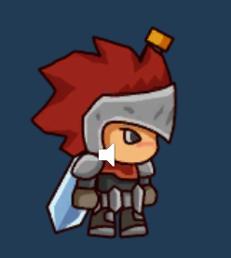

## *Figure 7:* (Bee)

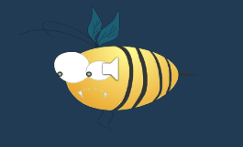

## *Figure 8:* (Mosquito)

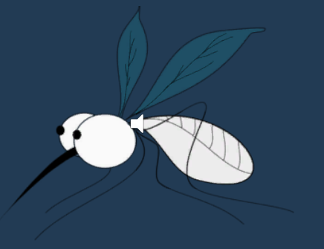

## 

## *Figure 9:* (Dragonfly)

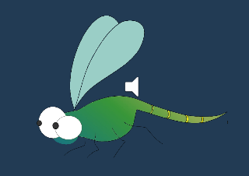

# “User Interface Appendix”

## *Figure 10:* (User Interface)

